Symmetry-Questions
Key Stage 3: 2003 Paper 1 Level 3-5
1.
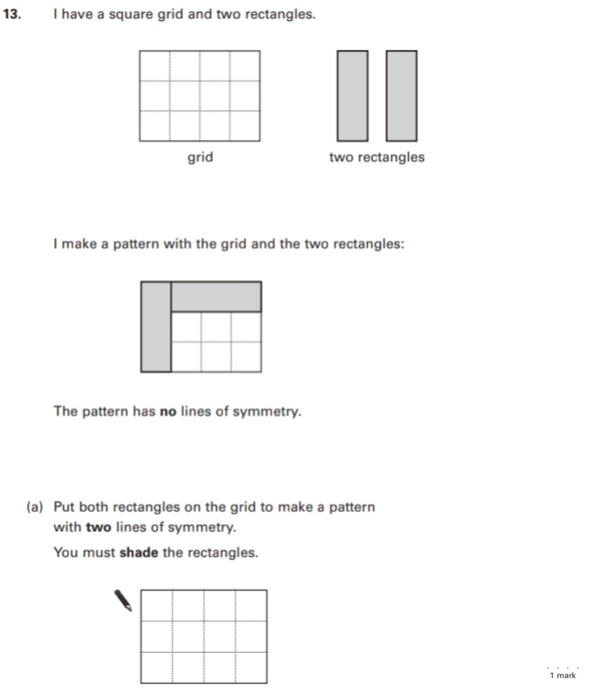
Key Stage 3: 2003 Paper 1 Level 4-6
2.
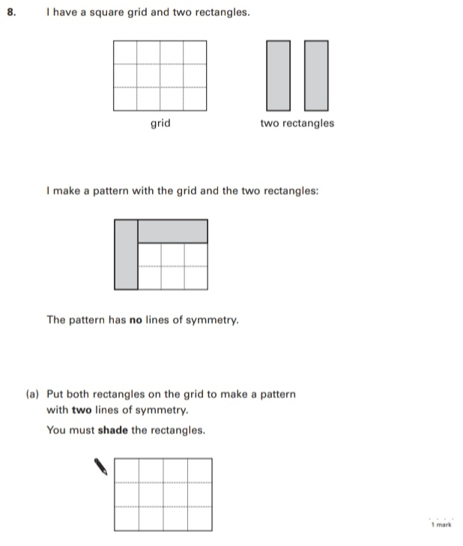
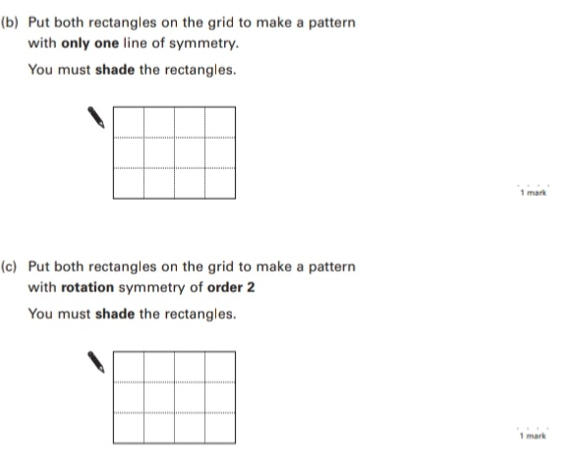
Key Stage 3: Paper 2 Level 4-6
3.
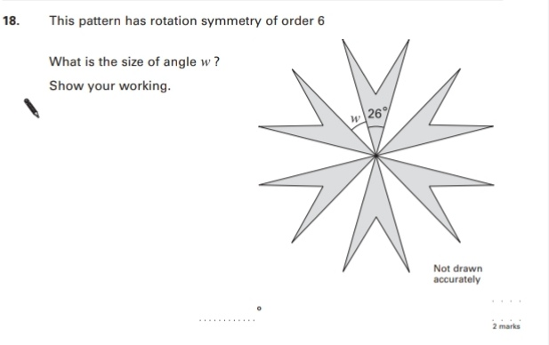
Key Stage 3: 2004 Paper 1 Level 3-5
4.
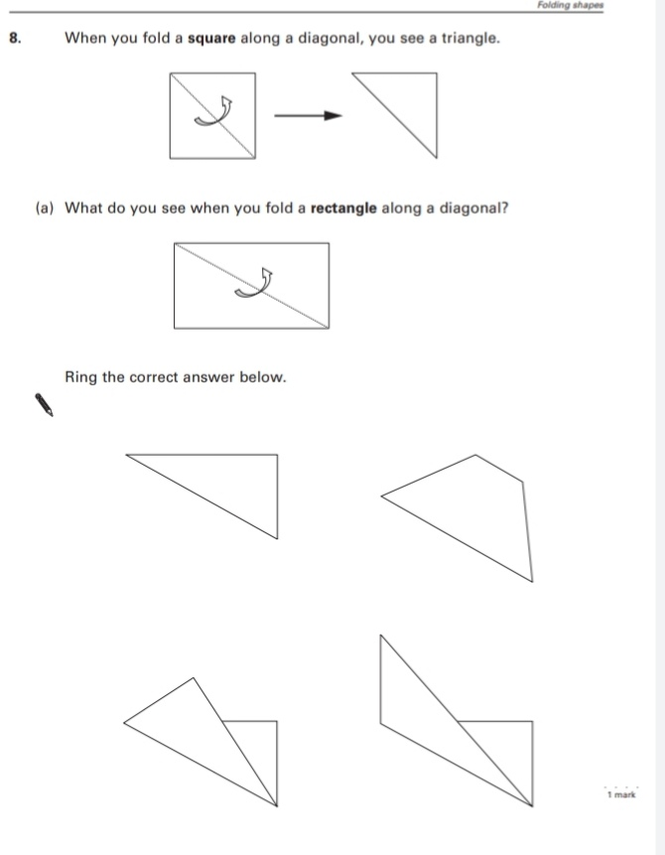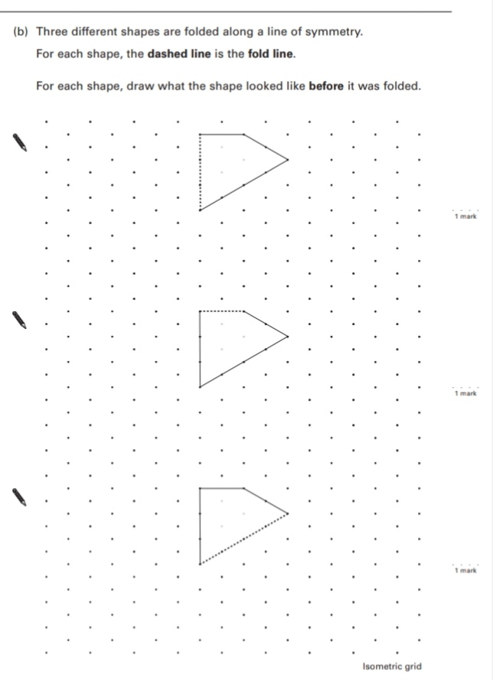
Key Stage 3: 2004 Paper 1 Level 4-6
5.
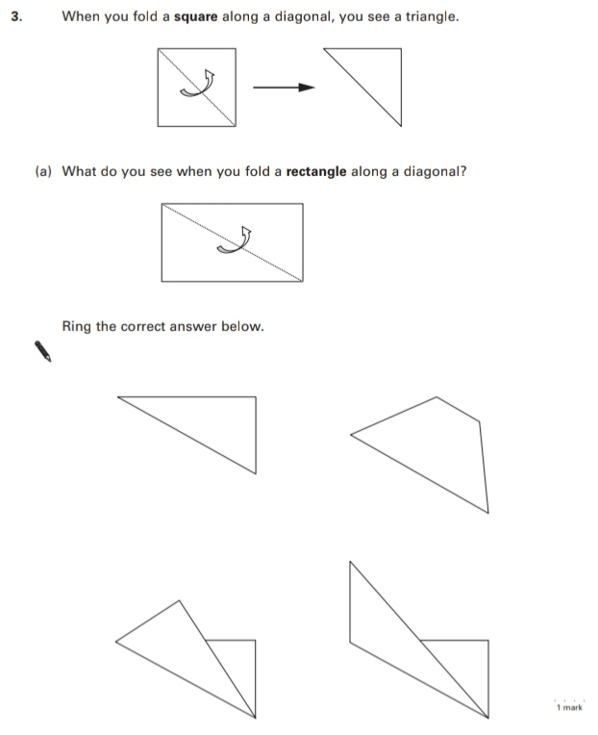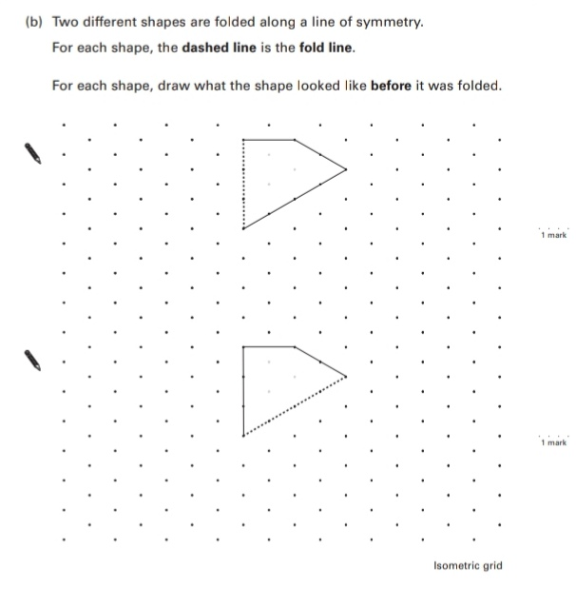
Key Stage 3: 2006 Paper 1 Level 3-5
6.
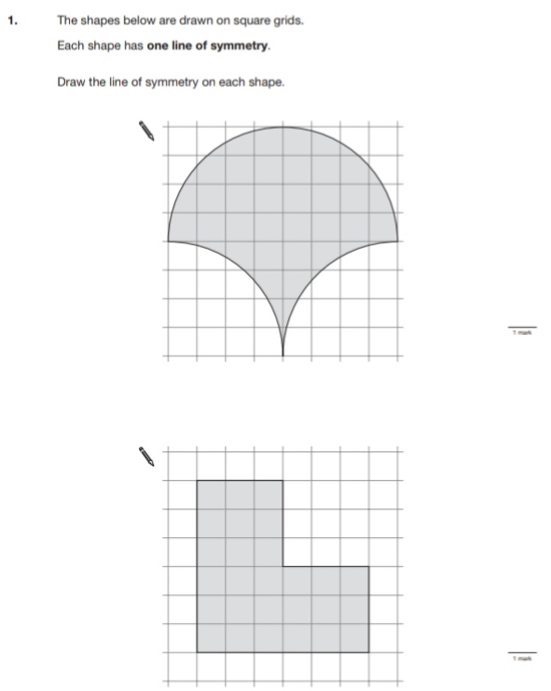
Key Stage 3: 2008 Paper 1 Level 3-5
7.
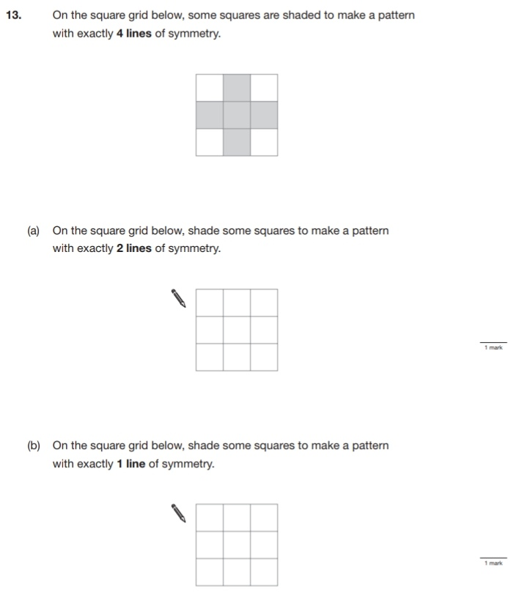
Key Stage 3: 2008 Paper 2 Level 3-5
8.
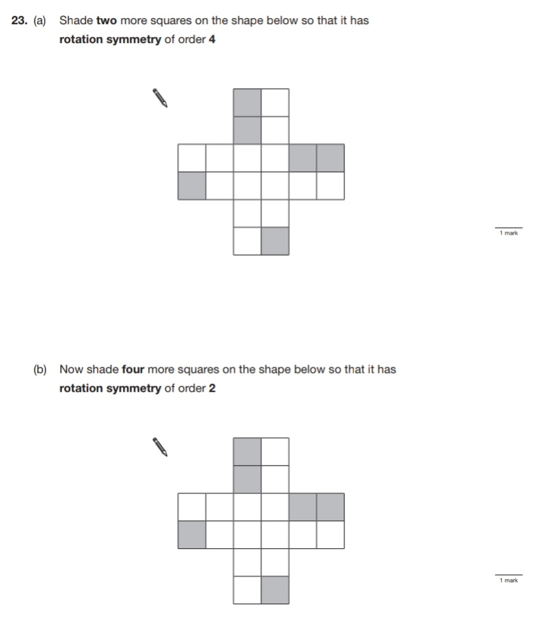
Key Stage 3: 2008 Paper 1 Level 4-6
9.
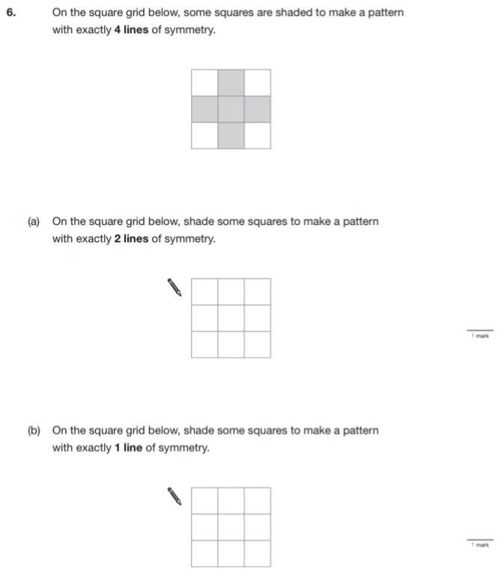
Key Stage 3: 2008 Paper 2 Level 4-6
10.
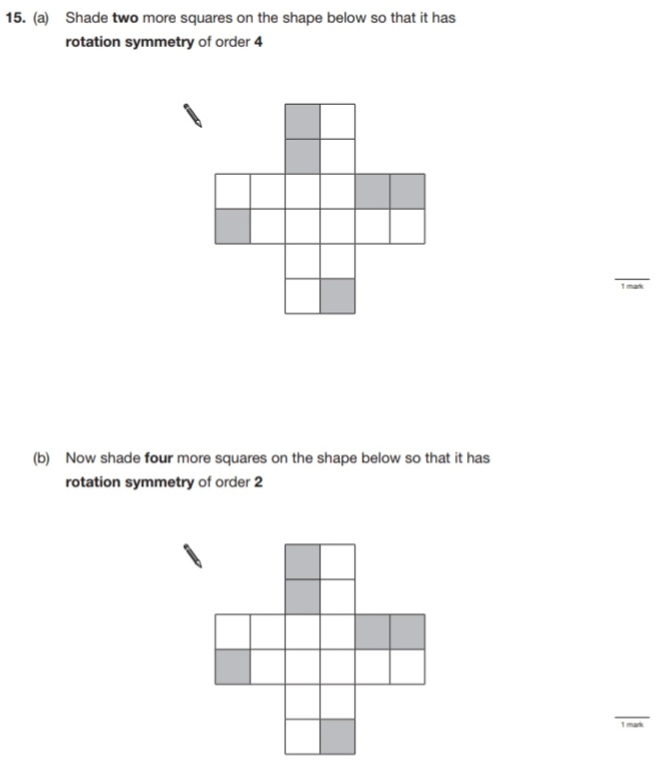
Key Stage 3: 2009 Paper 1 Level 3-5
11.
